

Practices for Secure Software Report

Table of Contents
Document Revision History 3
Client 3
Instructions 3
Developer 4
1. Algorithm Cipher 4
2. Certificate Generation 4
3. Deploy Cipher 4
4. Secure Communications 4
5. Secondary Testing 4
6. Functional Testing 4
7. Summary 4
8. Industry Standard Best Practices 4

Document Revision History

Version | Date | Author | Comments
1.0 | 10/18/2026 | Bryan Consuegra Cuellar | Final version for Artemis Financial

Client



Instructions

Submit these completed practices for a secure software report. Replace the bracketed text with the relevant information. You must document your process for writing secure communications and refactoring code that complies with software security testing protocols.

- Respond to the steps outlined below and include your findings.
- Respond using your own words. You may also choose to include images or supporting materials. If you include them, make certain to insert them in all the relevant locations in the document.
- Refer to the Project Two Guidelines and Rubric for more detailed instructions about each section of the template.

Developer
Bryan Consuegra Cuellar

Algorithm Cipher

TLS_ECDHE_ECDSA_WITH_AES_256_GCM_SHA384

This software will use a TLS cipher suite, the latest TLS 1.3 automatically uses ECDHE for every connection, and ECDSA for authentication algorithms. I have selected the bulk encryption cipher AES, a key size of 256 bits, I choose AES GCM mode over CBC mode (Galois/Counter Mode) has built-in authentication methods, and eliminates padding vulnerabilities.

The cipher suite uses a hash function SHA384 which better handles the future quantum-assisted analytical threats and a 384-bit level output. The bit levels refer to the length of the keys or hashed information measured in bits.

Cryptographic operations rely heavily on Pseudo-Random Number Generators (PRNGs); if they are predictable, the cryptographic operation will be unreliable, and an attacker can decipher them.

The bulk encryption AES_256_GCM uses a 256-bit key to lock and unlock the traffic stream and ensures data integrity; this algorithm lies under Symmetric encryption. On the other hand, for asymmetric encryption there are two algorithms that use a pair of keys. EDCHE for key exchange, and ECDSA for authentication.

The cryptographic graphic protocol SSL is not used anymore due to multiple vulnerabilities discovered, the current and most secure protocol is the transport layer security (TLS) 1.3, this protocol have changed how the cipher suite is written and omitting the specification of the key change, and authentication algorithms giving as a result TLS_AES_256_GCM_SHA384, These two algorithms are now removed they are just implemented by default due to the forward secrecy.

Certificate Generation
Insert a screenshot below of the CER file.

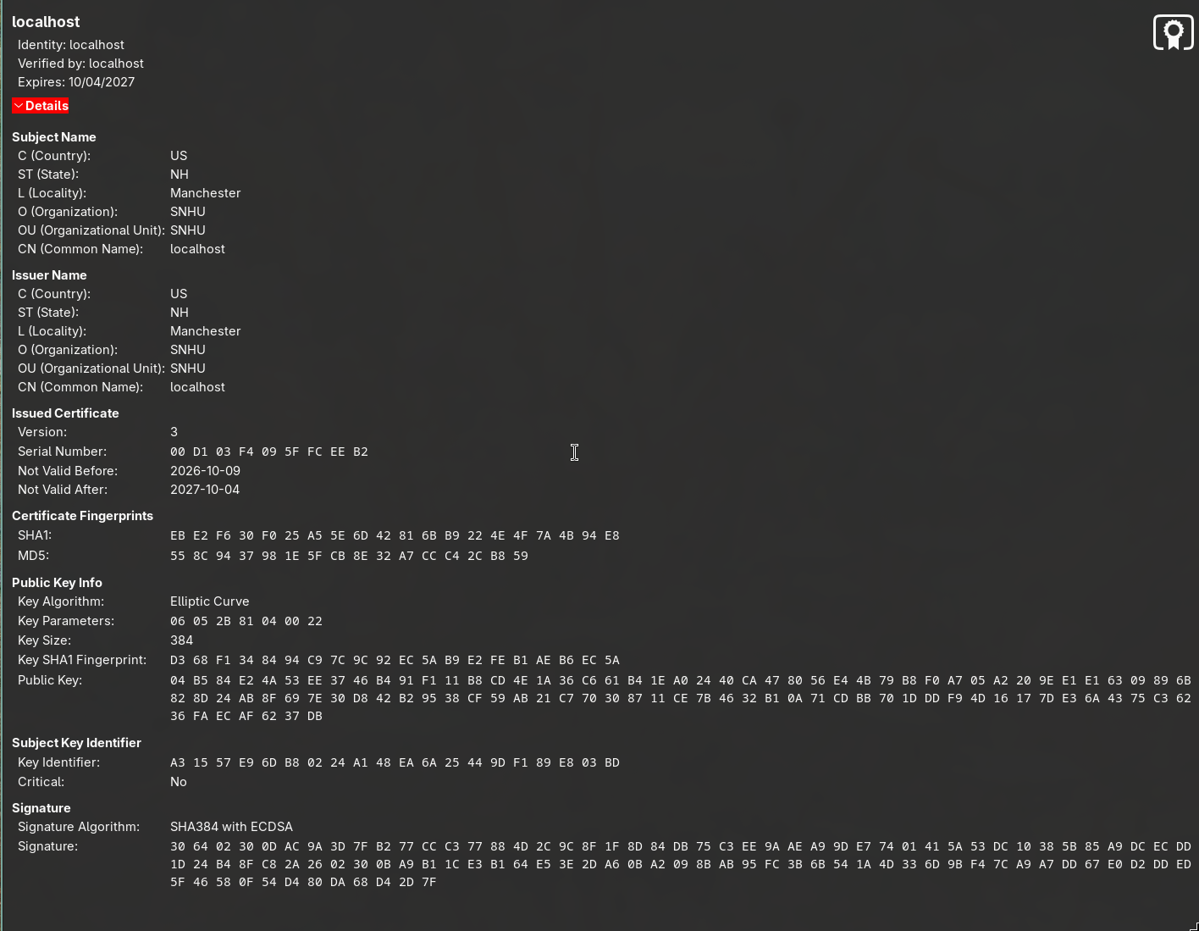

Deploy Cipher
Insert a screenshot below of the checksum verification.

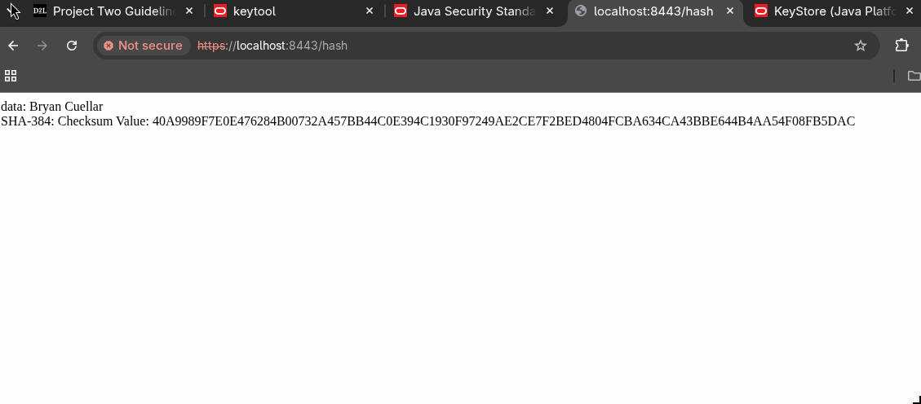

Secure Communications
Insert a screenshot below of the web browser that shows a secure webpage.

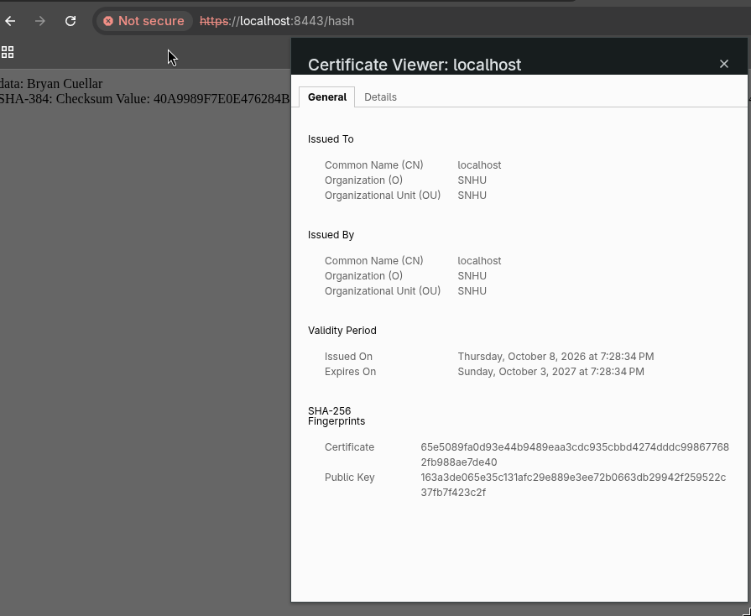

Secondary Testing
Insert screenshots below of the refactored code executed without errors and the dependency-check report.
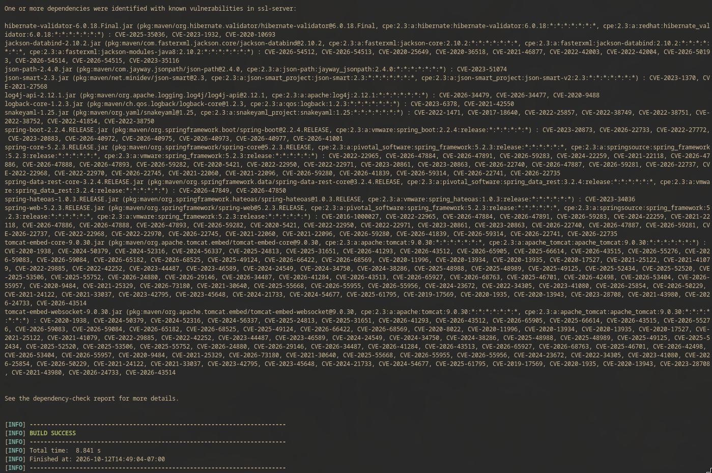
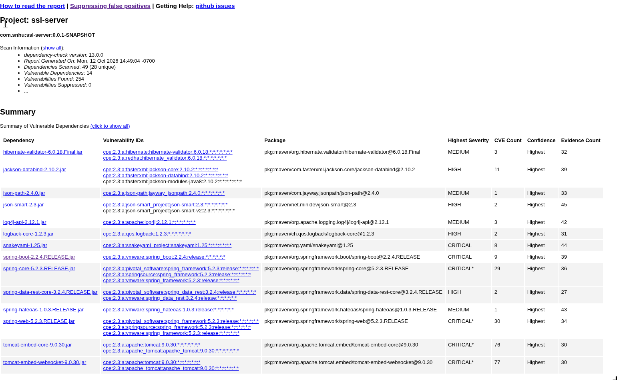

Functional Testing
Insert a screenshot below of the refactored code executed without errors.

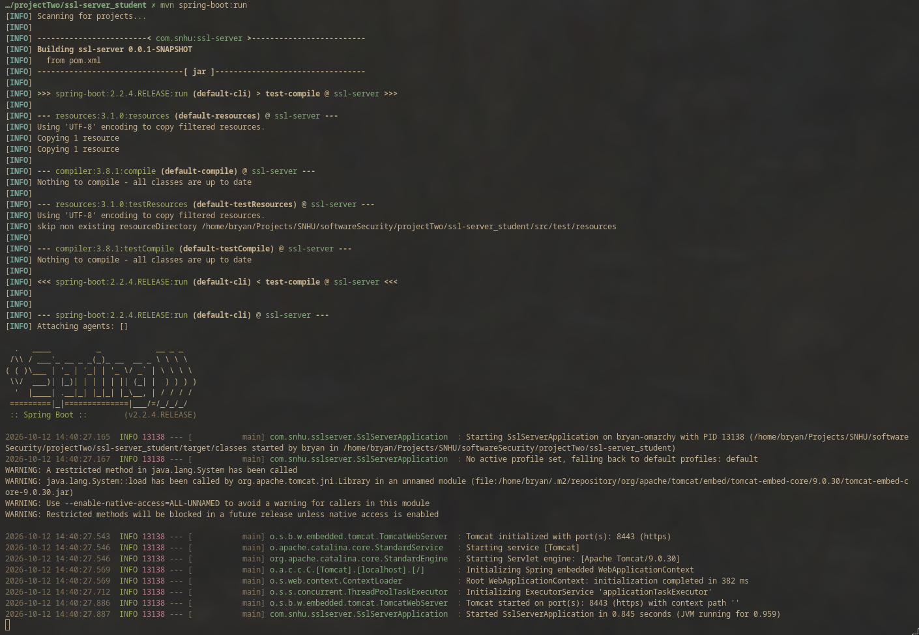

Summary
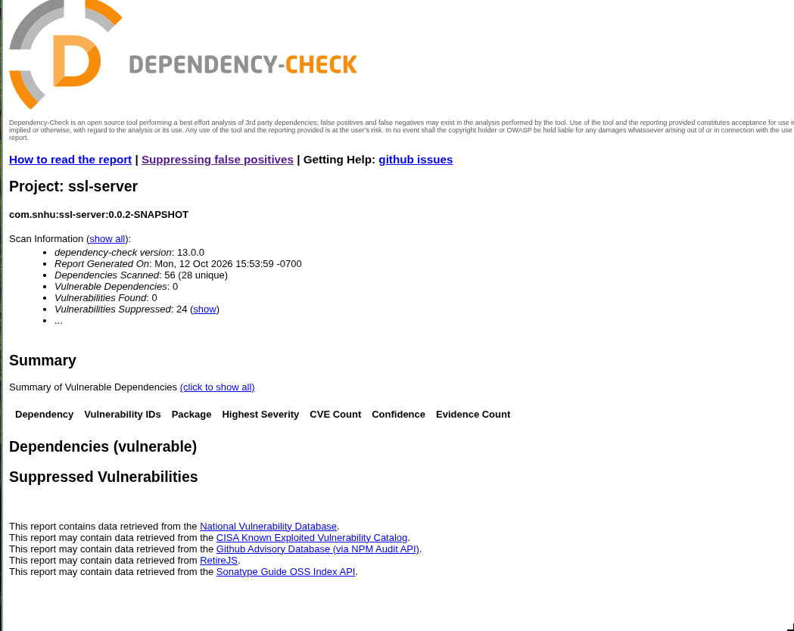

This project has been refactored to ensure secure software through the use of best practices. To begin, a security assessment was performed to generate a vulnerability report; this report gave me the needed information to start working on upgrading the compiler used for the software, along with the Spring Boot version. Java was upgraded to version 17, which is the minimum requirement for the latest Spring Boot release 4.1.1 to work. This upgrade has fixed almost all vulnerabilities in the report.
The next part of the refactoring was the implementation of a checksum to verify data integrity and detect corruption or errors that may occur during data transmission; a certificate was generated and self-signed to allow the use of a secure connection through the HTTPS protocol. I opened the web page, but the browser didn’t recognize the signer and did not grant a secure connection from a self-signed certificate.
Adding a checksum is an excellent way to ensure that the team can identify errors and tampering attacks. Making sure there are no alterations to the data by a third party, and the use of a certificate from a trusted source will also grant that the software website is legit and thrustful.

Industry Standard Best Practices

I use industry standards by following the core security best practices proposed by Manico and Detlefsen (2014). Ensuring input validation protects the software from any untrusted input that users or attackers can maliciously use, enforcing HTTPS connections for every page, resource, and session token, denying any authorization request for any resource that unauthorized users are trying to access, and implementing a safe cipher suite to avoid any kind of attack due to a weak or vulnerable cipher algorithm.

Applying these best practice standards will help Artemis Financial keep its software secure. Artemis is a company that handles different kinds and large amounts of sensitive data, and its customers' trust is built on how they secure the personal and financial information; a data leak or an attack can destroy customers’ financial lives. So applying these principles and enforcing the best practices in order to keep the software secure will grant Artemis success as a financial company.

References

Manico, J., & Detlefsen, A. (2014). Iron-clad Java: Building secure web applications. Oracle Press.

